Conference Echo Canceller HS-168
^{www.meicheng.com.tw}
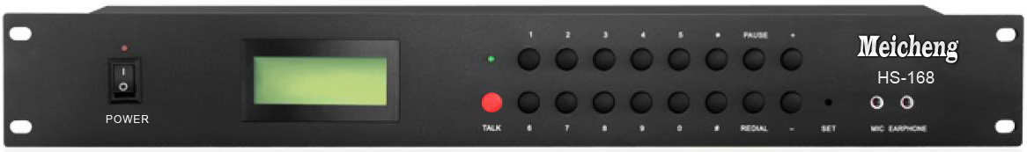
Telephone Meeting Coupler Function：  ●This telephone meeting coupler is compatible with FSK/DTMF system.  ●With 16 digit LCD display screen.  ●The LCD 5 level contrast is adjustable.  ●With the date and time settings.  ●This coupler supports the preset dial, redial and delete  .functions.  ●With eight kinds of ring type setting.  ●Can memory 16 set phone number display.  ●Have (REDIAL)、(HOLD) function. | 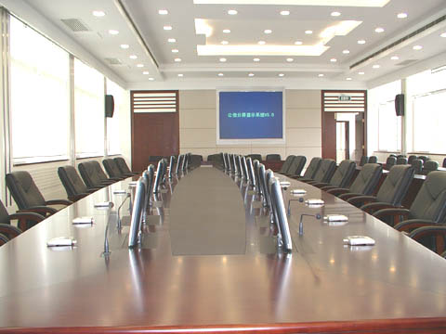
Dual-Tone Dial Function：
●The frequency of the low-frequency group：697Hz、770Hz、852Hz、941Hz。
●The frequency of high-frequency group：1209Hz、1336Hz、1477Hz。
●Single frequency deviation of ± 1.5% in the range.
●Dual tone multi-frequency signal,
●the frequency of the low frequency level of the single group：-9dBm±3dB.
●Dual-tone multi-frequency signal,
●high-frequency group level single frequency：-7dBm±3dB。
●Any combination of frequencies,
●the frequency group level is higher than the low base level 2 dB±1dB.
●At least the low overall level below the fundamental level caused by the harmonic intermodulation 20dB.
●Conditions of use：Ambient temperature -10 ℃～+40 ℃. Relative Humidity：10%～95%。
●Environmental Noise：≤60dB（A）. Atmospheric pressure：86～106kpa。
●The machine uses 110V AC power supply. Appearance: standard rack type.
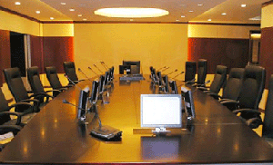
Meicheng® MEI CHENG AUDIO VIDEO CO., LTD.
Address: 13F., No.2, Jian 8th Rd., Jhonghe Dist., New Taipei City 235, Taiwan
Tel: +886(2) 8228 0311, Fax: +886(2) 8228 0319
Website : www.meicheng.com.tw Emai l:mei.cheng@msa.hinet.net

